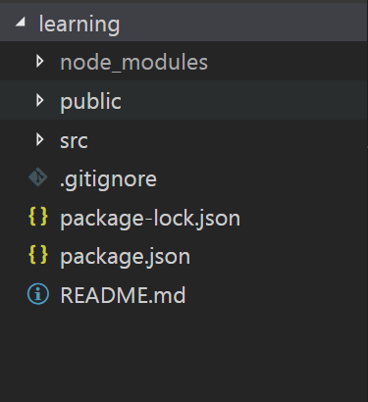

1. Here learning is application’s name
2. Node_modules : is library or extension of javascript
3. Public : is folder which contains index.html page which can be rendered publicly

- fabicon

- index.html : <div id=”root”> </div>

- manifest : data/details about application

4. src : source code

import React from 'react'; // ‘react’ is library or extension of javascript

public – index.html -> src – index.js -> App.js

ReactJS: all about component which works on OOPS (object oriented programing system/structure)

Class: is wrapper of data member/variable/property variable and function/methods

Constructor: is inbuilt function which invoke automatically when component will be created/rendered

Extends: to provide one class properties to another class

Render() : is inbuilt function which return template (html, css)

Return:

**Add new component in project**

Header.js

Footer.js

Body.js